Gobi Wall 2024: C14 Analysis
Lab No. | Sample type | Site and Context | ¹⁴C age (BP) | Error | 2 sigma (CE)
UCIAMS 1354 | Wood, saxaul | F42, Hilltop fortification | 1040 | 15 | 992-1025 (95.4%)
UCIAMS 1358 | Wood, saxaul | Garrison G05, Area C wall line | 920 | 15 | 1041-1109 (59.6%)  1114-1174 (35.8%)
UCIAMS 1353 | Wood, saxaul | Garrison G05, Area C wall line | 850 | 15 | 1164-1228 (95.4%)
UCIAMS 1357 | Wood, saxaul | Garrison G05, Area A garrison corner | 1050 | 15 | 988-1026 (95.4%)
UCIAMS 1359 | Charcoal | Garrison G05, Area A garrison corner | 955 | 15 | 1031-1054 (18.2%)  1075-1158 (77.3%)
UCIAMS 1364 | Charcoal | Garrison G10, Area D | 950 | 15 | 1033-1054 (16.1%)  1064-1068 (01.1%)  1073-1158 (78.2%)
UCIAMS 1363 | Charcoal | Garrison G10, Area D | 885 | 15 | 1053-1073 (05.4%)  1156-1219 (90.1%)
UCIAMS 1360 | Wood, saxaul | Garrison G10, Area D | 925 | 15 | 1040-1165 (95.4%)
UCIAMS 1361 | Charcoal | Garrison G10, Area C | 890 | 15 | 1053-1076 (12.3%)  1156-1216 (83.2%)
UCIAMS 1362 | Charcoal | Garrison G10, Area C | 870 | 15 | 1162-1219 (95.4%)
UCIAMS 1355 | Wood, saxaul | Garrison G06 | 925 | 15 | 1040-1165 (95.4%)
UCIAMS 1356 | Wood, poplar | Garrison G03 | 855 | 15 | 1165-1224 (95.4%)

Table 2: AMS ¹⁴C analysis of samples excavated from the South Gobi wall line and garrisons (OxCal 4.4, IntCal20, Bronk Ramsey 2021; Reimer et al. 2020).

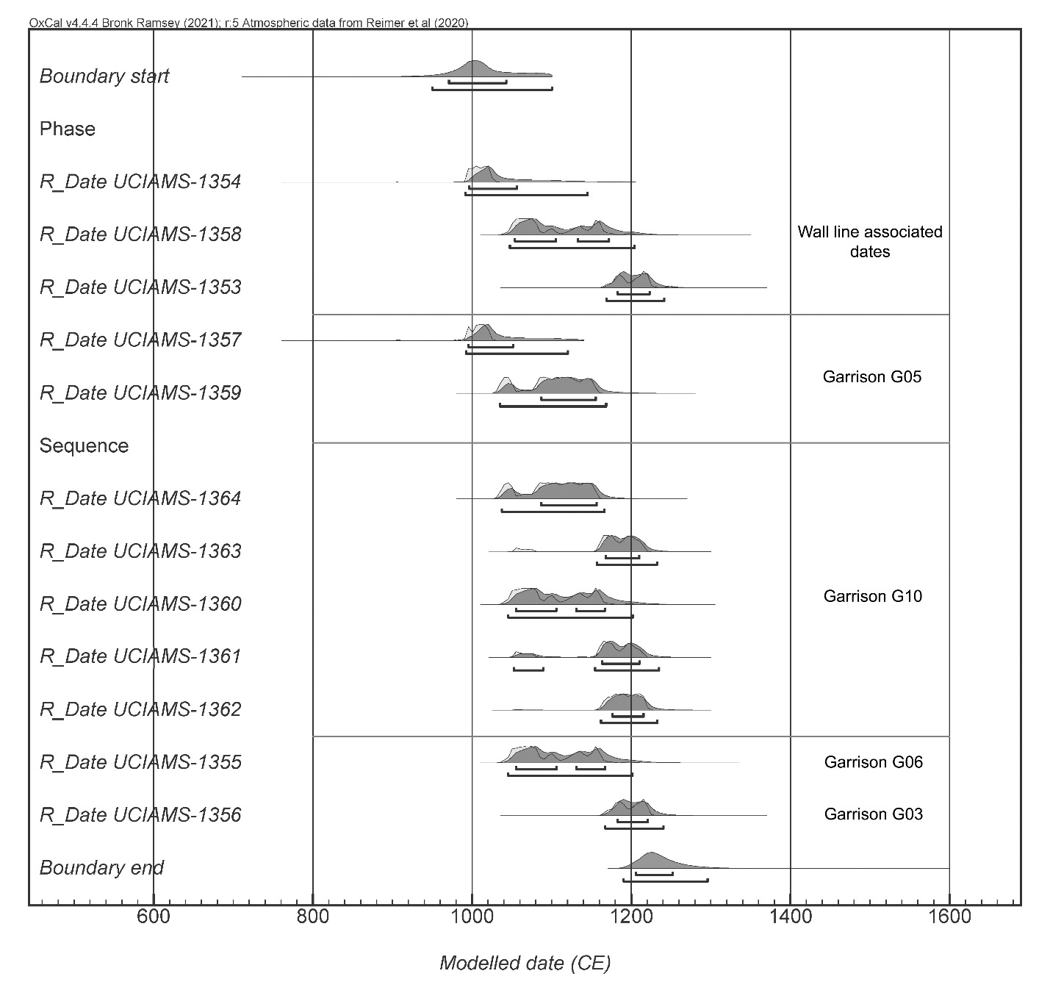
Figure 21. Bayesian modeled radiocarbon dates and boundaries using the Exponential Outlier method (Dee and Bronk Ramsey 2014).

